**Replication study “Validating the paraphrase methodology” by Scontras & Goodman**

**Introduction**

Semantics and pragmatics have always been a highly active field of research in linguistics.

The semantics and pragmatics of predicating properties can be ambiguous. This is especially true in plural sentence environments. An example of such is the problem of distributive vs. collective ambiguity of plural predication (Link, 1983, 1987, 1998; Scha, 1984; Landman, 1989a, 1989b, 1996; Lasersohn, 1988, 1990, 1995, 1998; Schwarzschild, 1994, 1996).

For example, when exposed to an utterance such as “The boxes are heavy”, it is semantically viable to interpret the predicate “heavy” in a distributive (i.e. the boxes each are heavy) as well as in a collective (i.e. the boxes together are heavy) manner. Remarkably, some predicates such as “big” are not open to a collective interpretation. This phenomenon was coined “stubborn distributivity” (Quine, 1960; Schwarzschild, 2011; Syrett, 2015; Vázquez Rojas Maldonado, 2012; Zhang, 2013).

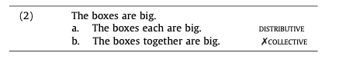

Although this phenomenon is well documented, it is still unclear as to why certain predicates appear to be unsuitable to be used in a collective way.

Scontras & Goodman in their paper “Resolving uncertainty in plural predication” (2017) investigate which characteristics about predicates influence or determine their behavior in plural predication in a series of experiments. This study aims to replicate their first experiment, which measures the interpretation of plural predications and thereby investigates distributive vs. collective ambiguity of plural predication. Using the properties of ambiguous sentence frames and stubbornly distributive predications, we assess whether the words “each” and “together” can be used to unambiguously access distributive and collective semantic interpretations.

In the present study, participants are asked to imagine a warehouse worker describing boxes to another worker. They are exposed to an utterance prompt in the form of a descriptive sentence and the visual representation of two stacks of boxes simultaneously. The experimental task is to decide which stack of boxes the utterance refers to. The referents each represent a collective or distributive interpretation of the utterance prompt.

If, as hypothesized, “each” and “together” act as disambiguators for plural prediction, results should indicate an unambious referent that participants chose for trials featuring these words. A distributive “each” should denote the distributive referent while a collective “together” should denote the collective referent. We also expect to see a distributive interpretation by the participants for utterances featuring the stubbornly distributive words “big” and “tall”.

In an exploratory effort, the present study will analyse the influence of all variables on the time it takes participants to choose a referent from trial onset. Further, we will look at participant’s referent choice for ambiguous bare utterances featuring “heavy”, for which a split in referent choice is expected -with the scenario condition featuring “moves” to yield higher rates of collective referent choice. An example stimulus of the present study is presented in *figure 1* below.

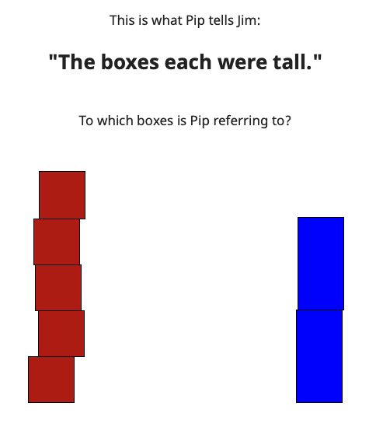

**Figure 1: Example stimulus of the plural prediction experiment**

**Design & Methods**

**Materials**

As our visual stimulus, we use a single image throughout the experiment sourced from the original study (Scontras & Goodman, 2017). The image features two distinct stacks of boxes, one of which is composed of five smaller boxes, while the other is composed of two larger boxes (see figure 1).

The utterance prompt follows the form “The boxes V1 were V2”, with V1 = “each”/ “together”/ bare (none) and V2 = “big”/ “heavy”/“tall”.

We have a mixed 2x3x3 factorial design with the following levels for each factor: 1. *scenario* (“move”, “inspect”) 2. *sentence frames* (“each”,“together”, bare (none)) 3. *predicate* (“big”, “heavy, ”tall”).

Importantly, while the condition *scenario* is measured between subjects, conditions *sentence frames* and *predicate* are measured within subjects.

**Hypotheses**

1. All else being equal, for ambiguous sentence frames (factor-level combination: sentence frame = bare) featuring predicates “big” and “tall”, we expect participants to assign a distributive interpretation reflected in referent choice.
2. All else being equal, for sentence frames featuring "together" (for factor level combination sentence frame == together), in utterances such as "The boxes together were tall", we expect participants to assign a collective interpretation reflected in referent choice for the majority of trials.
3. All else being equal, for sentence frames featuring "each" (for factor level combination sentence frame == each), in utterances such as "The boxes each were tall", we expect participants to assign a distributive interpretation reflected in referent choice for the majority of trials.

**Structure**

The experiment is implemented using the magpie[1] architecture and hosted on netlify[2]. It exhibits the following structure:

1. Introduction
2. General instructions (varies in between subject for condition 1)
3. Testing phase (trials vary within subject for conditions 2 and 3)
4. Post-experiment questionnaire + Thank you

Participants are first welcomed and introduced to Pip, an imaginary figure who is a factory worker. They are informed that Pip either “inspects” or “moves boxes” as part of the *scenario* condition, through an explanatory text and related image (see figure 2).

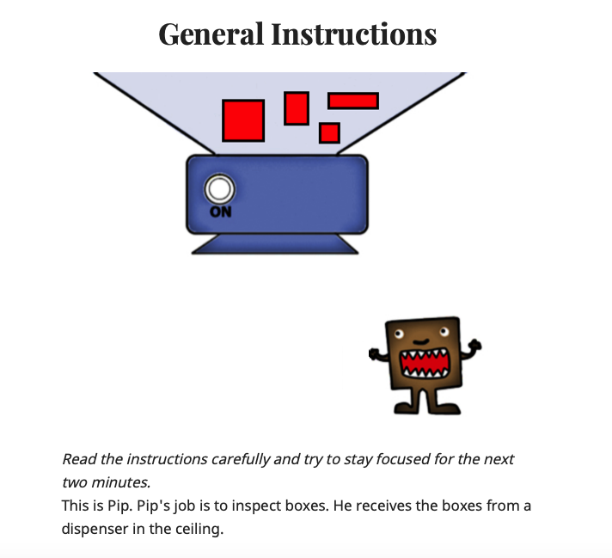

**Figure 2: General instructions varying according to the *scenario* condition*.***

Furthermore, the Pip figure is displayed handling a moving cart for “move” or without handling a cart for “inspect”. The *scenario* condition is administered in a balanced fashion. A “continue” button leads to the subsequent page featuring general instructions, telling the participants a story of how Pip describes the boxes in question to his friend Jim and instructing them to help Jim understand which boxes Pip refers to.

The “begin” button leads into the experimental trials. Pip uses one of three distinct predicates, “big”, “heavy” and “tall” for the *predicate* condition within one of three distinct sentence frames, using “each”, “together” or “bare”(none) in his utterance for the *sentence frame* condition. The utterance is displayed alongside an image of two stacks of boxes with the question posed “To which boxes is Pip referring to?” (see figure 3). Participants are presented with nine trials in total, offering all possible combinations of *predicate* and *sentence frame* in a random fashion.

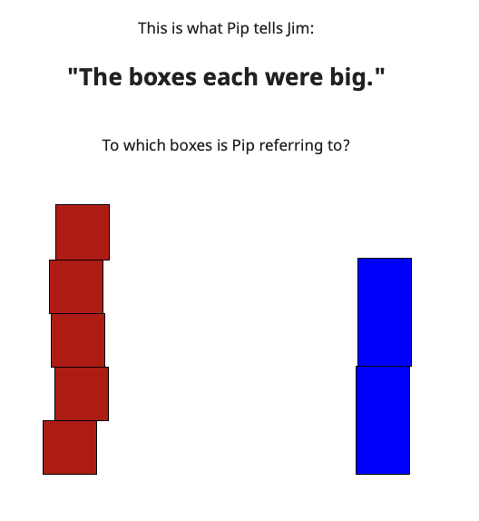

**Figure 3: One experimental trial featuring an utterance and two images.**

Participants are asked to choose between the referents, one of which implies a collective interpretation of the utterance (e.g. five small boxes, Fig. 3, left) and one of which implies a distributive interpretation (e.g. two large boxes which were together smaller than the five small boxes, Fig. 3, right). Participants are presented with the option to click either one of the images of the two stacks of boxes directly. After choosing one set of boxes, participants are immediately forwarded to the next trial.

At the end of all trials, participants are presented with an optional questionnaire asking “age”, “gender” (with options: male, female, other), level of education (with options: highschool graduate (diploma, Abitur or equivalent), University degree (Bachelor), Higher degree), native Languages: (i.e. the language(s) spoken at home when you were a child) with an open format section and lastly, an option to provide further comments.

**References**

Kamp, H., & Partee, B. (1995). Prototype theory and compositionality. Cognition, 57, 129–191.

Landman, F. (1989a). Groups I. Linguistics and Philosophy, 12, 559–605.

Landman, F. (1989b). Groups II. Linguistics and Philosophy, 12, 723–744.

Landman, F. (1996). Plurality. In S. Lappin (Ed.), Handbook of contemporary semantics (pp. 425–457). Oxford: Blackwell.

Lasersohn, P. (1988). A semantics for groups and events Ph. D. thesis. The Ohio State University.

Lasersohn, P. (1990). Group action and spatio-temporal proximity. Linguistics and Philosophy, 13, 179–206.

Lasersohn, P. N. (1995). Plurality, conjunction and events. Dordrecht: Kluwer Academic Publishers.

Lasersohn, P. (1998). Generalized distributivity operators. Linguistics and Philosophy, 21, 83–93.

Lassiter, D., & Goodman, N. D. (2013). Context, scale structure, and statistics in the interpretation of positive-form adjectives. In T. Snider (Ed.). Proceedings of SALT (Vol. 23, pp. 587–610). CLC Publications.

Link, G. (1983). The logical analysis of plurals and mass terms. In R. Bäuerle, C. Schwarze, & A. von Stechow (Eds.), Meaning, use, and interpretation of language (pp. 302–323). Berlin: de Gruyter.

Link, G. (1987). Generalized quantifiers and plurals. In P. Gärdenfors (Ed.), Generalized quantifiers (pp. 151–180). Dordrecht: D. Reidel.

Link, G. (1998). Ten years of research on plurals – where do we stand? In F. Hamm & E. Hinrichs (Eds.), Plurality and quantification. Studies in linguistics and philosophy (Vol. 69, pp. 19–54). Netherlands: Springer.

Quine, W. V. O. (1960). Word and object. Cambridge, MA: MIT Press.

Scha, R. (1984). Distributive, collective and cumulative quantification. In Truth,interpretation, and information (pp. 131–158). Dordrecht: Foris.

Schwarzschild, R. (1994). Plurals, presuppositions and the sources of distributivity. Natural Language Semantics, 2(3), 201–248.

Schwarzschild, R. (1996). Pluralities. Dordrecht: Kluwer Academic Publishers.

Schwarzschild, R. (2011). Stubborn distributivity, multiparticipant nouns and the count/mass distinction. In S. Lima, K. Mullin, & B. Smith (Eds.). Proceedings of NELS (Vol. 39, pp. 661–678). Amherst, MA: Graduate Linguistics Students Association, University of Massachusetts.

Scontras, G., & Goodman, N. D. (2017). Resolving uncertainty in plural predication. *Cognition*, *168*, 294–311. https://doi.org/10.1016/j.cognition.2017.07.002

Syrett, K. (2015). Mapping properties to individuals in language acquisition. In BUCLD 39 proceedings. Cascadilla Press.

Vázquez Rojas Maldonado, V. (2012). The syntax and semantics of Purépecha noun phrases and the mass/count distinction Ph. D. thesis. New York University.

Zhang, N. N. (2013). Classifier structures in Mandarin Chinese. Berlin: Mouton de Gruyter.

1. https://magpie-ea.github.io/magpie-site/
2. https://www.netlify.com